PSG COLLEGE OF TECHNOLOGY, COIMBATORE -4
DEPARTMENT OF APPLIED MATHEMATICS AND COMPUTATIONAL SCIENCES
III M.Sc Data Science - 5th SEMESTER
15XD56 - JAVA PROGRAMMING LAB PROBLEM SHEET – 3

Objectives: Developing JAVA programs to study OOP concepts
- Polymorphism ii) Inheritance

- Implement the inheritance hierarchy shown in Figure 11. Have Account and SavingAccount classes in a single file named BankAccount. The defaultInterestRate field in the SavingAccount class is static with an initial value of 2.5. The setDefaultInterestRate() is a static function.
Have the BankAccount class to create objects of Account and SavingAcount classes, invoke deposit and withdraw methods on them, and invoke the setDefaultInterestRate() and the applyMonthlyInterest() on the SavingAccount object.
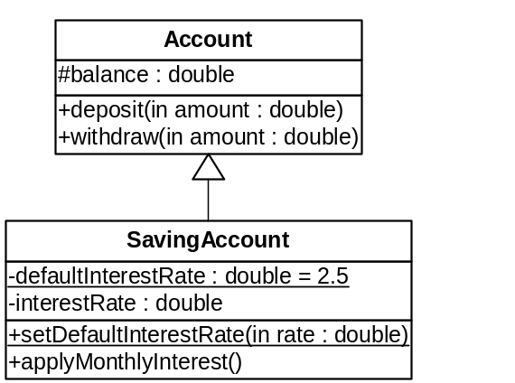
Figure 1

- The task is to write a program for handling the employees of a company. The underlying Task is to support run time polymorphism using inheritance , overriding methods. Hint : SUPER keyword is expected in constructor and methods. Use an array of objects for clerks and directors.

Class Employee
The main class is Employee.
An employee has the following instance variables:
- age: an integer
- salary: an integer
On employees the following methods work:
- Employee: sets all parameters
- increaseSalary: multiplies the salary by (1 + salaryIncrease)
- checkRetirement: returns true if age exceeds 65, otherwise false
- paySalary(int i): prints that company pays salary to employee i
- display: lists all variables on a single line

Class Clerk
Clerk is a derived class from Employee.
A clerk has one extra instance variable:
- illDays: an integer counting the number of days the person was ill during the last calendar year
On clerks the following additional methods work:
- addIllDays: adds one to illDays
- getIllDays: returns the value of illDays
- display: adds the additional variable to the variables of Employee

Class Director
Director is a derived class from Employee. A director has one extra instance variable:
- gratification: a double giving the fraction of the profit this director gets at the end of the year
On director the following additional methods work:
- payGratification(int i): prints how much gratification the company pays to employee i
- display: adds the additional variable to the variables of Employee

Class Company
Then there is the class Company. It has the following instance variables:
- numberOfEmployees: an integer
- profit: an integer
- employee: an array of Employee

Methods working on companies are:
- Company(int maxSize): creates a company with an array of length maxSize
set Employee = new Employee[maxSize];
- addClerk(int i) adds a clerk at the end of the employee array
employee[i] = new Clerk(members);
addDirector(int i)() adds a director at the end of the employee array
employee[i] = new Director(members)
- printCompany() prints the details of employees.

Class CompanyTest
On top of all, there is a class CompanyTest. It contains main method. It creates a company with 3 directors and 10 clerks.
**********
- Consider the UML conceptual model shown in 2. You will be writing class definitions and the test driver program following the instructions below.
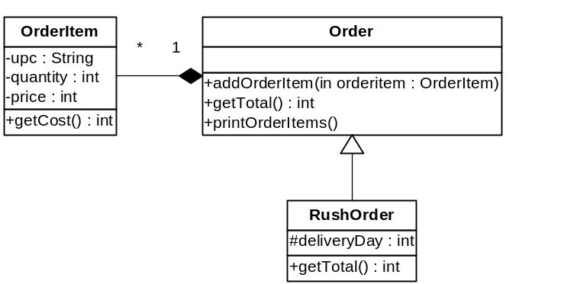
Figure 2 Conceptual Model
Add the class definitions of OrderItem, Order and RushOrder classes in their separate .java files. Note that all of these classes are public.
OrderItem class has a String upc, an integer quantity and an integer price, all private. The getCost() method returns the multiplication of its quantity and price.
Order class has a list of OrderItem objects. The addOrderItem() method takes an object of OrderItem as the parameter and stores it in the list. The getTotal() method returns the total cost of all order items in the order. The printOrderItems() method prints information about each order item via the toString() method of the OrderItem class.
RushOrder class extends the Order class. It has an integer instance variable deliveryDay, a protected member, which represents in how many days the order should be delivered. The getTotal() method overrides the definition of the super class in the following way: It first invokes the getTotal() of the super class to find the total for all items in the order. It then adds the delivery charge. The delivery charge for one day delivery is $25, for two day delivery is $15, for three day delivery is $10. It is free for four or more days. Note that, the delivery charge should be added only if there are items in the order. It means if the getTotal() of the super class returns 0, do not add delivery charge, but just return 0.
Introduce Delivery as a test driver in the default package. It should execute as follows:
- Create an array of four Order objects, calling it orders. The first object is an instance of Order class, the second is an instance of RushOrder class with one day delivery, the third object is an instance of RushOrder class with two day delivery and the forth object is an instance of RushOrder class with three day delivery.
- Prompt the user to enter the UPC code for an item or “done” to quit. Read the user input.
  - While the user enter a UPC (anything other than “done”), prompt for and read the quantity.
  - Generate a random number from 50 to 100 for the price.
  - Create an OrderItem object with UPC, quantity and price.
  - Generate a random number from 1 to 7 for the delivery day.
  - Add the order item to the element of the orders array corresponding to the delivery day via the addOrderItem(). If delivery day is four or bigger, add the order item into the first element, which is the instance of Order class. If the delivery day is one, add it to the second element of the orders array, which is the instance of the RushOrder class with one day delivery, and so on.
  - Continue the loop until either user enters “done”.
- For each order in the orders array:
  - Print out the type of order via the toString() methods.
  - Print out all the order items.
  - Print out the subtotal for this order.
- Print out the total cost in all of the orders.

